FOI Ref: 6040
Category(ies): Trust - Contracts
Subject: Ophthalmology request
Date Received: 29/09/21

Your request: | Our response:
- EOI's submitted by CCG and/or NHS Trust to seek provision of ophthalmology services for 2020/2021, 2021/22 and 2022/23 including service item and indicative number of patients. | Please contact the Commissioner @  roccg.foi@nhs.net
- Ophthalmology contracts awarded by CCG and/or NHS Trust to seek provision of ophthalmology services for 2020//2021, 2021/22 and 2022/23 including service item and indicative number of patients. | Please contact the Commissioner @  roccg.foi@nhs.net
- EOI submitted by CCG and/or NHS Trust to seek provision of cataract services for 2020/2021, 2021/22 and 2022/23 including indicative patient numbers. | Please contact the Commissioner @  roccg.foi@nhs.net
- Ophthalmology contracts awarded by CCG and/or NHS Trust to seek provision of cataract services for 2020//2021 and 2021/22 including indicative patient numbers. | Please contact the Commissioner @  roccg.foi@nhs.net
- 2020/21 and 2021/22 annualized activity levels of contract values at: 1.) CCG Level, 2.) Provider Level. | 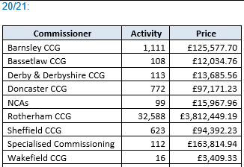  21/22 (M1-M5):  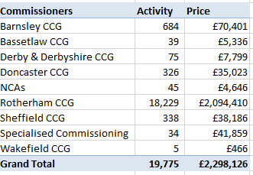
- End dates of your current commissioned ophthalmology providers? | Please contact the Commissioner @  roccg.foi@nhs.net
- Members of your local ICS involved in ophthalmology decision making for the ICS footprint? | Please contact the Commissioner @  roccg.foi@nhs.net
- (left blank)
- Who is currently identified as the ICS HVLC cataract hub for 2022? | Please contact the Commissioner @  roccg.foi@nhs.net

