FOI Ref: 6200
Category(ies): Staff - Structure
Subject: Structure of Procurement
Date Received: 24/01/2022

Your request: | Our response:
Please could you provide a structure chart of your Procurement departments via email, where possible including the names of each staff member.
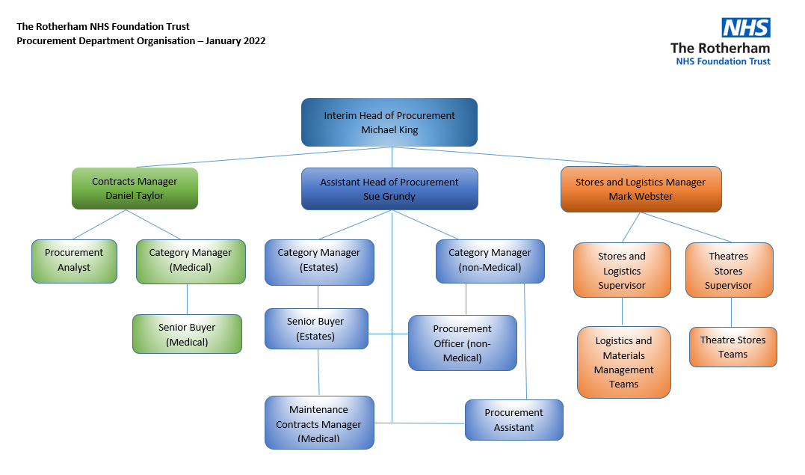
* The names of relevant individuals are detailed in the attached. The provision of these contact details does not imply consent for unsolicited correspondence on your part. As per Section 122 of the Data Protection Act 2018, permission is not given to use these details for unsolicited contact.
Right to prevent processing for purposes of direct marketing.
S122 (5) direct marketing” means the communication (by whatever means) of advertising or marketing material which is directed to a particular individual.

** Please note TRFT has withheld the names and direct contact details of staff below Band 8a level in accordance with the personal information exemption at section 40(2) and 40(3) of the Freedom of Information Act 2000 which state:
• if disclosure would breach any of the Data Protection Principles in the Data Protection Act,
• if the data subject would not themselves be entitled to access it under the Data Protection Act because one of the Data Protection Act subject access exemptions apply (but subject to the public interest test)
These individuals are not in public facing roles and have an expectation that their names and direct contact details will not be put into the public domain. It would be unfair for us to disclose their details and would contravene the first data protection principle.

