**Safeguarding & Vulnerabilities Team**

**Annual Report**

**2020 / 2021**



CONTENTS

Page 3 Introduction and overview

Page 4 Adult Safeguarding Activity

Page 4 Key Performance Indicators & Standards

Page 5 Safeguarding Adult Reviews

Page 5 Domestic Homicide Reviews

Page 5 Partnership Working – Adult Safeguarding

Page 8 Learning Disability Service

Page 9 Child Death Review

Page 11 Safeguarding Children Activity

Page 12 Safeguarding Children Developments

Page 14 Key Performance Indicators & Standards

Page 14 Serious Case Reviews

Page 15 Safeguarding Supervision

Page 15 Partnership Working – Safeguarding Children

Page 17 Looked After Children

Page 20 Safeguarding Governance Arrangements

Page 21 CQC Improvement Plan

Page 24 Risks and Mitigation

Page 26 Summary & Conclusion

Page 27 Future Priorities

Page 29 Summary Reports, Qs 1 – 4

Page 33 Appendix 1 - TRFT Strategies for Safeguarding Vulnerable Service Users

Page 36 Appendix 2 - Safeguarding & Vulnerabilities Team

Page 37 Appendix 3 - TRFT & Partnership Organisational Governance Structure

Page 38 Appendix 4 - Safeguarding Standards – Exception Report

Introduction and Overview

This Annual Report seeks to inform the Trust Board of the safeguarding activity within The Rotherham NHS Foundation Trust (TRFT) during the period 2020/2021. Additionally the report aims to:

* Provide assurance to the Trust Board that the Trust is fulfilling its statutory obligations
* Assure service commissioners and regulatory bodies that the Trust’s activity over the year has developed in terms of preventing abuse and reducing harm to vulnerable service users
* To inform the Board and wider Trust staff of the activities and function of the Safeguarding & Vulnerabilities Team, and of the progress with the Safeguarding work plan, which enables the TRFT Strategy for Safeguarding Vulnerable Services Users (Appendix 1) to be fully realised and embedded within the organisation.

The Report incorporates Adult and Children Safeguarding. The Named Professional from each specialist area has inputted to the content. The Integrated Safeguarding Team is managed by the Head of Safeguarding with executive leadership of the Chief Nurse and Deputy Chief Nurse (Refer to Appendix 2 - Management and Professional Leadership Chart). The governance and assurance arrangements within Safeguarding remain robust and are outlined within Appendix 3 (TRFT and Partnership Organisational Governance Structure).

This has been a challenging year, with Covid-19 impacting on services Trustwide and the CQC inspection in July 2020, resulting in a comprehensive and detailed improvement plan.

This Annual Report sets out to identify and describe the key risks that were managed during the year and provides a summary of some the key activities undertaken each quarter. In addition, as part of the summary and conclusion, it describes the key priorities and areas identified for improvement in relation to safeguarding activity for implementation during 2021/2022.

The Report provides an overview of activities over the last 12 months in relation to:

Adult Safeguarding Activity

***Jean Summerfield, Head of Safeguarding***

***Safeguarding & Vulnerabilities Team***

***Lynda Briggs, LAC Lead Nurse***

Learning Disability Service

Child Death Review

Children Safeguarding Activity

Looked after Children

Governance

Risks and Mitigations

Partnership Working

Adult Safeguarding Activity

A blended approach to training delivery continues to be used, with the offering of internal face-to-face training, e-learning and external taught sessions with Rotherham Metropolitan Borough Council (RMBC).

Bespoke sessions have been delivered throughout the Trust to medical, nursing and allied health colleagues, in both adult and children’s specialities, acute and community services. Mental Health training is provided in partnership with RDaSH.

A robust training programme is in place for Prevent; This is included in the Trust Induction programme. Training arrangements for this are regularly updated, in line with Government guidance.

There is ongoing review of training requirements allocated to staff, in line with the Safeguarding Adults Intercollegiate document. This is done in partnership with our colleagues in Learning & Development to ensure that TRFT staff MaST requirements appropriately reflect their roles.

Training compliance is monitored via Safeguarding Key Performance Indicators and the Safeguarding Standards set by the Clinical Commissioning Group (CCG). These are reviewed at the monthly Operational Safeguarding Group which reports to the Strategic Safeguarding Group, held quarterly.

2020/21 saw an increase in patients admitted due to poor mental health. TRFT have continued to work in partnership with RDaSH to ensure that, for this group of patient, there is parity of esteem between their mental and physical health needs.

**Adult Safeguarding Training Compliance – Figures at 31/03/2021**

|  |  |  |  |
| --- | --- | --- | --- |
| **Adult Safeguarding Training** | **Rag Rating** | **Percentage Achieved 2020/2021** | **Percentage Achieved**  **2019/2020** |
| Level 1 | Amber | 80% | 100% |
| Level 2 | Green | 90% | 82.42% |
| Level 3 | Green | 100% | 100% |
| Level 4 | Green | 100% | 100% |
| Prevent Level 1 & 2 | Green | 92% | 91.13% |
| Prevent Level 3 | Green | 94% | 89.72% |
| Dementia | Green | 98% | 97.36% |
| Mental Health L1 | Green | 90% |  |
| Mental Health L3 | Amber | 70% | 26.09% |

Key Performance Indicators (KPI) & Standards

Adult Safeguarding are required to satisfy the requirements of KPIs and Safeguarding Standards, as set by the Clinical Commissioning Group (CCG). These include offering assurance on a diverse range of safeguarding activity throughout the Trust.

Both the Safeguarding Standards and the Key Performance Indicators are reported quarterly to the Trust Safeguarding Strategic Group and Partners, including representation from the Clinical Commissioning Group, RMBC, Rotherham Children Safeguarding Partnership and Rotherham Safeguarding Adult Board are members.

An exception report is included at Appendix 4.

Safeguarding Adults Reviews (SAR)

One SAR was conducted in 20/21. Sadly this was linked to a SAR completed in 19/20. The action plan for this was completed. The multi-agency action plan will be developed when the RSAB review is complete. All learning from reviews is shared appropriately across the Trust, either by being incorporated into training or by the use of 7-minute briefings.

Domestic Homicide Reviews

The statutory requirement related to domestic homicide reviews came into force in April 2011. The focus is a multiagency approach with the purpose of identifying learning.

One case went forward as a Domestic Homicide Review (DHR) in the 2020/2021 period. There were no internal recommendations for TRFT from this review. The multi-agency report is in progress. Any actions from this will be monitored through the Operational Safeguarding Group.

The Trust is represented at the Domestic & Sexual Abuse Priority Group by the Head of Safeguarding.

Partnership Working – adult safeguarding

The Trust is represented at the Rotherham Safeguarding Adult Board by the Chief Nurse. Her deputy is the Head of Safeguarding.

There is representation at all four sub-groups of the Board to ensure that TRFT has a voice in shaping Adult Safeguarding arrangements across Rotherham.

The Adult Safeguarding Team continues to work in partnership with RMBC to provide ‘health’ input for safeguarding investigations. This involves offering support to RMBC colleagues around investigations, Decision Making Meetings and preparations for Outcomes Meetings, even where there is no TRFT involvement. This represents the Trust’s continued commitment to partnership working.

In 2020/2021 no safeguarding concerns involving Trust services required progression to an Outcomes Meeting. This means that these concerns were managed and resolved in the initial concern stage.

As per Rotherham Adult Safeguarding Procedures, the Trust receives concerns raised about the safety and well-being of adults at risk (of neglect or abuse). For 2020/2021, 603 were received, equating to approximately 50 per month. This represents a 20% increase on figures for last year (508). Of these, a proportion (371) were passed to partner organisations to screen. These are cases where the concerns did not involve care delivered by TRFT, or which required joint-screening.

The Trust is represented at the Rotherham Multi-Agency Risk Assessment (MARAC) meetings. The HARK (Harassment, attack, rape, kick) form is now established in UECC and has been positively received. This was a specific measure taken to abbreviate the form which has resulted in better reporting within UECC.

A total of 936 cases were brought to MARAC, approximately 39 cases per fortnightly meeting, and information about the family reviewed and shared to enable the multi-agency management of the risk related to each case. This represents a 4% increase on last year’s figures. The local area increase reflects the national increase at the time during the early weeks of the Covid 19 pandemic and subsequent lockdown. MARAC meetings have been maintained virtually through ‘Teams’ meetings to ensure continuity of risk assessment and safety planning for the high-risk cases. In addition, MATAC (Multiagency Tasking and Co-ordination Meetings) commenced in February 2021 to review high risk and serial perpetrators of domestic abuse with interventions to address support, prevention, diversion, disruption and enforcement in order to reduce harm. The safeguarding team are represented at these meetings.

The management of patients who lack capacity to consent to care and treatment within the hospital continues to be a priority for TRFT. Work continues to embed improvements made regarding the implementation of the MCA. Requests for Deprivation of Liberty Safeguards (DoLS) continue to follow the year-on-year upward trend, demonstrating evidence of the continued application of the MCA in practice.

Adult Safeguarding again saw an increase in activity of 8% in DoLS applications to 510. Of the DoLS requests, none were authorised by RMBC. The Adult Safeguarding Team continue to provide leadership and support to ensure the processes are embedded fully across the Trust.

The Mental Capacity Act has been reviewed and amended. The expected change from DoLS to Liberty Protection Standards (LPS) was delayed and is now expected to be implemented in April 2022.

TRFT has recruited to a 1WTE Band 8A MCA Lead/Named Nurse Adult Safeguarding post, leading the LPS project plan and ensuring that we are prepared for the coming changes and will be able to meet the statutory requirements.

Learning Disability Service

The Learning Disability (LD) Team at TRFT continues to grow and strive to deliver excellent standards of care for people with LD and/or Autism. Within the Team we now have two Trainee Nursing Associates, who are specialising in LD. Following their two-year training, which completes later this year, they will have substantive positions within the LD Team.

This growth in the team allows us to visit, review and assist more people who are using the Trust facilities, in turn, improving the standard of care they receive and improving the experience for them. We continue as a Team and Trust to develop bespoke pathways, making individual ‘reasonable adjustments’ for people coming into the Trust. These are especially successful with patients coming through on our day surgery pathways, with patients and their teams/families giving excellent feedback.

The Team also visits people who have been discharged from hospital, to look to plan, prevent or minimise repeat admissions to hospitals, working with primary care and RDaSH Trust.

A current project that the LD Team are supporting is within our Urgent and Emergency Care Centre (UECC). The Team is working with the department to gain Autism Accreditation. This scheme is through the National Autistic Society and will help to raise the standard of care and the experience we give to patients and visitors with Autism. All of the autism awareness training that will be associated with this programme will be delivered by ‘experts with experience’. This is also a project that we hope to extend through all wards and departments.

We are continuing to progress how we develop from feedback given to us from our patients, families and carers. We now have representation on our LD and autism sub-group from the parent of an individual with neuro-diverse needs and Autism. We continue to develop and welcome new members to this group. It is vital that patient experience directly shapes and improves the services within the Trust. This group feeds directly into the Trust Patient Experience Group.

Around the Trust, the LD Team have also increased the amount of information boards there are in relation to LD and/or Autism. These act as a visual reminder to staff and visitors to the Trust regarding the LD Team and give information about the hospital passport, how to contact the team, and how we can give help and support.

Our Team is involved with the LD Mortality Reviews (LeDeR). These are reviews of deaths of people with Learning Disabilities. This is positive for our Trust to be able to learn from the thematic data this produces and improve our services accordingly.

The LD Team at TRFT continues to work in partnership with local organisations within the third sector. We work closely with Speak Up, a Rotherham advocacy organisation which employs staff and has volunteers with Autism and LD, service providers such as Voyage, Exemplar, Mencap and our Local Authority.

We hope to appoint a medical lead from the Trust for the LD Team in the near future. Having expert medical oversight will be a hugely positive achievement for patient care at TRFT and will provide clinical guidance for the Team.

The Team offers bespoke training within the Trust around LD and Autism. This training offer also extends to our local universities, for both undergraduate adult nursing programmes, postgraduate nurse training and Trainee nursing associate programmes.

Child Death Review

The child death review (CDR) service has developed at a fast pace during the last year and has attracted interest from local and national Trusts to discuss and emulate the model we have embedded in Rotherham.

The CDR team aims to learn from all child deaths whilst delivering an excellent service for bereaved parents and carers.

**What’s working well in Rotherham?**

* The Trust is represented at Rotherham Child Death Overview Panel (CDOP) and Regional CDOP.
* The introduction of the role of the Lead Nurse for Child Death within TRFT in April 2020 has proved fundamental in developing, embedding and supporting the CDR process in Rotherham. Learning from audit, local and national themes and trends is shared, and where appropriate, has influenced change in local practice.
* The appointment of the role of keyworker has proved invaluable in highlighting the need for the parental/carer voice to be heard during the CDR process. Parental /carer feedback has been crucial to identifying key learning, particularly in relation to service delivery in the first couple of weeks following a child death. Bereaved parents/carers now have a single point of contact Mon-Friday, 9am-5pm to whom they can turn to for information on the CDR process. The keyworker discharges their care once parents/carers have been offered contact and seen by Designated Child Death Paediatrician, Lead Nurse and Keyworker following the child death review meeting.
* The CDR meetings for all child deaths have worked effectively in terms of attendance and participation. The keyworker attends the CDR meeting to ensure that the voice of parents/carer are heard and taken into account.
* Direct contact and liaison with the National Mortality Data Base (NCMD) has enabled CDOP to remain compliant with CDR guidance e.g. grading system used to identify modifiable factors.
* The CDOP and the CDR process has continued during the COVID pandemic and a number of outstanding historical cases have now been concluded at CDOP.
* There has been improved liaison with Leeds Children’s Hospital, Sheffield Children’s Hospital and Jessop Wing, leading to improved information sharing for deaths of children resident in Rotherham occurring outside of the area.
* The CDR meetings and use of the eCDOP system has enabled more focused discussion and evaluation of the case at CDOP, allowing more time to discuss learning points.
* There has been increased awareness of the CDR process in obstetrics and maternity services in TRFT resulting in timely initiation of relevant processes.
* The use of Rapid Response Meetings for relevant cases continues to offer an effective step at the early stages of a death to identify support for the family including siblings and schools.
* Safe Sleep in children’s and maternity acute services audit has taken place. The audit identified excellent practice in SCBU and a good level of knowledge and understanding of national guidance amongst practitioners. However, national guidance was not always promoted when the baby/child was in receipt of care from TRFT. The audit included attendance at UECC and paediatric outpatient services.
* Developed links with LeDeR to ensure smooth referral of necessary cases.

**What are our plans for 2021-2022**

* Rotherham will host the South Yorkshire CDOP from September 2021. In conjunction with members, we will consider a number of thematic reviews to take place throughout the year.
* Improved liaison with the Coroner’s Office in relation to role and function of coroner’s officer and keyworker, and how they can work jointly to support families/carers.
* Audit and assurance of TRFT compliance with child death review statutory and operational guidance will take place.
* Embed child death review training on paediatric and obstetric registrar induction days and paediatric nurse training days.
* Consider and develop effective systems for cascading learning from CDOP to the wider partnership.
* Development session for CDOP members.
* Review Rotherham SUDI/C multi -agency safeguarding procedures.
* Consider the learning from National Reviews – eg NCMD Annual Report and webinars.
* TRFT will undertake self-assessment in relation to Bereavement Care Standards and identify actions, which may need to be addressed before the Trust can achieve National Care Pathways 2020, Bereavement Care Standards.

In 2020/2021 Rotherham recorded 11 child deaths in total; this is significantly below the average for years 2017-2020 (average 18 child deaths).

Rotherham CDOP cases discussed April 2020 – March 2021 (cases discussed do not collate to deaths occurred in 20-21 financial year).

|  |  |  |
| --- | --- | --- |
| **Category of death** | **Number** | **Modifiable Factors** |
| Perinatal/neonatal event | 2 | 1 |
| Sudden unexpected, unexplained death | 3 | 0 |
| Chromosomal, genetic and congenital anomalies | 5 | 1 |
| Infection | 2 | 1 |
| Acute medical or surgical condition | 1 | 0 |
| Trauma and other external factors | 1 | 0 |
| Chronic medical condition | 0 | - |
| Deliberately inflicted injury or neglect | 0 | - |
| Suicide or deliberately inflicted self-harm | 0 | - |
| Total | 14 | 3 |

Safeguarding Children Activity

Mandatory training remains a key priority. The development of our new training strategy, Think Family, commenced in the last quarter of 2020/21, with a focus on joint training for children’s and adults competencies, meaning staff can acquire competencies in level 2 and level 3 at the same time, dependent on job role and requirements. This will be implemented and reviewed in 2021/2022. Overall figures for training compliance at levels 1, 2, and 3 have remained consistent, around the 85/90% compliance, which is all the more remarkable considering the additional pressures that the Trust has faced with COVID 19. The monitoring of training compliance continues via the Operational Safeguarding Group and Safeguarding Strategic Group. Assurance is provided to the Quality Committee from the data provided by Electronic Staff Record (ESR).

**Safeguarding Children Training Compliance - Figures at 31/03/2021**

|  |  |  |  |
| --- | --- | --- | --- |
| Children Safeguarding Training | **Rag Rating** | Percentage Achieved  **2020/2021** | Percentage Achieved  **2019/2020** |
| **Level 1** | Amber | 76% | 100% |
| Level 2 | Amber | 84% | 84.64% |
| Level 3 | Amber | 84% | 83.56% |
| Level 4 | Amber | 80% | 100% |

All TRFT E-learning packages and face to face training is compliant with intercollegiate requirements. There has been a continued emphasis on additional opportunities to support a blended approach to learning with ‘bespoke’ opportunities including attendance at safeguarding meetings, practitioner learning events, tailored feedback supervision sessions, incident review, ‘stop the shift’ presentations and Safeguarding Awareness Week with the key themes of Domestic Abuse, Child Sexual Exploitation and gender bias.

The Named Nurses conducted a joint review of staff MaST competencies with the Learning and development team. It was recognised that due to the variety of routes that staff can use to gain their competencies over the three year period as per Royal College of Paediatrics & Child Health (RCPCH) ‘Intercollegiate Document’ (2019), continual review and progression would be required to ensure the accuracy of the data obtained.

Safeguarding Children Developments

In 2020/2021 a key focus has continued to be the development and upskilling of the TRFT work force in order to increase practitioner confidence and competence in managing safeguarding children concerns.

The safeguarding team have implemented a number of ‘Stop The Shifts’ focusing on key messages e.g. Discharge Planning Meetings, Multi Agency Processes and Practice Resolution. During Covid all multi agency meetings have taken place via Teams which has benefited service users by having the right people at the right time to co-ordinate safe plans for discharge.

This has been progressed by the development of designated Safeguarding Children Champions across acute and community service areas. There has been expansion of standardised safeguarding children’s competencies within key service areas to enhance level 3 skills and knowledge.

In addition to the Safeguarding Champions, the team have also been able to train additional staff in becoming Safeguarding Children’s Supervisors to complement the safeguarding supervision offer across the Trust and support compliance for staff working with children.

Daily Safeguarding Children Huddles have been embedded in the acute children’s services, maternity, UECC and children’s ward which support meaningful case discussions and case escalations. This has emphasised that Safeguarding is a core business across the children’s pathway. The huddles have also been extended to the fracture clinic and SCBU, with work ongoing to introduce the huddles within community children’s services.

The use of paper safeguarding records was reviewed and Electronic safeguarding records for children and families were created through joint working with IT teams. Ward managers and paediatric practice educators agreed to implement these, with bespoke training delivered to staff.

Within maternity e-safeguarding care plans went live and staff were supported with six bespoke training sessions to support the transition to paperless. The plan was agreed with Children’s ward areas to review 3 months after implementation.

Additional safeguarding alerts and prompts in UECC were expanded on the existing electronic templates. Further expansion of e-safeguarding templates in the acute Trust is planned e.g. community midwifery, SCBU, gynaecology wards and EPAU for 2021/22.

7-minute safeguarding briefings continue to be produced on a monthly basis, providing an opportunity to disseminate key current information across the Trust. Alongside these, appreciative enquiries are also produced which highlight areas of good practice to share across the workforce. This allows the safeguarding team to promote positive safeguarding messages to engage and encourage staff with the safeguarding processes.

The safeguarding team are responsible for reviewing and updating safeguarding policies. The Trust’s Female Genital Mutilation (FGM) policy has been updated in line with recent changes to national guidance. Amendments were made to TRFT’s Surrogacy Policy following changes to national guidance. These were reviewed by the Trust’s legal team to support the transition. A Trust’s Child Protection Medical Assessment Policy has also been developed in line with the national standards and a training package for medical colleagues developed in conjunction with new starter training to reinforce multiagency processes. This is co-delivered in conjunction with the RMBC children’s social care, service manager and safeguarding team.

Partnership work has been undertaken to develop a Child Protection Medical Assessment ‘surge plan’ during Covid 19. It was anticipated that there could potentially be more children requiring child protection medical assessments (CPMA) and the surge plan would therefore ensure that all children who required a CPMA would receive one within the set partnership timescales. This was a direct result of national networking and work to consider the priorities and demand that could be placed on the acute setting as a result of the Covid 19 situation.

Policy and processes have been implemented following the CQC inspection which identified the need for a more robust safeguarding system to identify vulnerable 16 and 17 year olds admitted to adult wards. The implementation involved building mandatory safeguarding checks into the Meditech patient record admission template. This prompted staff to request safeguarding checks which would provide information of known risks or vulnerabilities to support the assessment and ensure any emerging concerns are actioned appropriately.

The implementation involved the safeguarding team raising the awareness of child safeguarding processes across adult wards. It was key that, although infrequent, staff on adult wards were aware of who to go to for support and advice in the event of a vulnerable child being cared for on their ward.

In addition, arrangements were put in place for the safeguarding team have oversight of these admissions. IT built in a mechanism from admission of a 16 -17 year old which would trigger an email notification to the safeguarding team. It is acknowledged the workforce will need regular reinforcement of the safeguarding children’s processes and review of the implementation.

Key Performance Indicators (KPI) & Standards

Children’s Safeguarding are required to provide assurance through the KPIs and Safeguarding Standards, as set by the Clinical Commissioning Group (CCG). These include offering assurance on a diverse range of safeguarding activity throughout the Trust, including supervision and training, division specific activity, e.g. LAC health assessments, CSE referrals and Child Protection Medicals.

Both the Safeguarding Standards and the Key Performance Indicators are reported quarterly to the Trust Safeguarding Strategic Group and Partners, including representation from the Clinical Commissioning Group, Local Authority, Local Children Safeguarding Partnership and Local Safeguarding Adult Board are members.

Following review of the terms of reference of the Operational and Strategic safeguarding meetings, plans were being implemented for the divisions to take ownership of their individual KPIs and standards with the requirement to report monthly to the Operational meeting to present their information.

Serious Case Reviews

Within this annual report year there have been two Serious Case Reviews (SCRs). Both were initiated by other Local Authorities, with no recommendations for Rotherham. TRFT has continued to contribute to multi-agency action plans from SCRs in the previous annual reporting period.

No Serious Incidents involving children have been identified in this reporting period however, action plans from serious incidents from the last reporting year have been progressed and learning disseminated across the Trust. A practitioner thematic-review learning event for 3 cases was held September 2020 supported by the Rotherham Safeguarding Children Partnership (RSCP) which focussed on risks and vulnerabilities with teenage parents and bruising and injury in the non-mobile baby. While it would have been favourable to undertake such an event face-to-face Covid 19 proved to be a challenge and the event was undertaken virtually, via Teams.

Safeguarding Supervision

During 2020/21 the Supervision Model has continued to be embedded across the Trust. Within this annual reporting period, the Safeguarding Team have coordinated 1:1, group and adhoc safeguarding supervision sessions on a monthly basis. Due to the Covid 19 restrictions the sessions in lockdown were completed virtually.

The Children’s Safeguarding Supervisors’ training package continues to be delivered to colleagues from acute and community services. A training session was delivered in January 2021, with 5 further supervisors trained. Further dates for April 2021 and June 2021 are planned. This will support the offer of safeguarding supervision across the divisions with more scope for additional sessions within the departments, which will subsequently help to improve compliance. The challenge has been finding practitioners who have a keen interest but who will also be supported by their managers to undertake this additional role.

Compliance continues to be monitored through the Operational Safeguarding Group. In October 2020 there was a transfer of staff compliance from manual recording to Electronic Staff Records (ESR). There have been some difficulties with this related to the accuracy in recording staff who require supervision, resulting in manual database cross referencing against the workforce data, a time consuming exercise. This has been identified as an area that requires review and monitoring.

Due to COVID 19, an online safeguarding supervision video package was developed for staff to work through to enable them to maintain group compliance. This would allow staff to have time out for reflection and a requirement to complete the ‘signs of safety’ tool to demonstrate their learning. The safeguarding team implemented a process for reviewing and verifying the content of the learning record and then agreeing final compliance sign-off and then notifying the Learning and Development, who would record the achievement of this competency.

For those staff who required 1-1 supervision, sessions continued virtually.

Partnership Working – safeguarding children

Partnership working, as directed by Working Together to Safeguard Children (2018), and the Children Acts (1989 & 2004), underpins the ethos and values of the Safeguarding Children’s Team.

The Trust is represented at executive level by the Chief Nurse, or her deputy, the Head of Safeguarding, who attend the Rotherham Safeguarding Children Partnership (RSCP) and Rotherham Adult Safeguarding Board (RSAB) meetings. The Safeguarding Named Nurses and Named Midwife attend the safeguarding delivery groups of the RSCP, in line with Section 11 of the Children Act 2004 requirements. Actions and information is reported back to TRFT Safeguarding Operational Meeting with any future plans e.g. injuries in children, safeguarding risk assessment tool, parent/ carer child protection enquiries process leaflet.

Over the last 12 months the Children’s Safeguarding Team have continued to work closely with our RSCP and Local Authority colleagues to improve the outcomes for children and young people. This has enabled joint priority setting, enabling the Partnership to respond to emerging themes, thereby ensuring safeguarding processes are robust and effective.

It has been recognised that communications and language between health and social care has not always been effective. From this joint discussions have taken place regularly which has given additional focus to improving and formalising the use of the practice resolution process, ensuing staff were aware of how to escalate and professionally challenge partners, with support where necessary.

The development of TRFT guidance on practice resolution was supported by walk-about sessions and stop-the-shift interventions across maternity, acute and community clinical areas. This links to the Rotherham Partnership Protocol. Further work is planned to develop the Multi-agency Safeguarding Hub (MASH) ‘baby clinic’ to consider information and multiagency planning for pregnant women.

TRFT Partnership arrangements are evidenced by TRFT’s engagement with our Local Authority (LA) partners as well South Yorkshire Police (SYP), Rotherham Clinical Commissioning Group (RCCG) and other Health providers.

During Covid 19 lockdown an additional weekly vulnerabilities meeting was commenced to ensure partners were working effectively, able to respond to any new need and could consider new arrangements of working. In addition, the TRFT monthly Partnership Meeting (merged October 2020 with UECC Partnership Operational Meeting) continued with a virtual meeting to continue with the ethos of collective, joint solution-focused actions.

Active partnership working with the Multi-Agency Safeguarding Hub (MASH) continues. TRFT has a substantive post in MASH, and is represented at all relevant MASH meetings.

During this annual report period there have been 422 initial Child Protection Case Conferences (a 1% increase on the previous year) and 735 Review Child Protection Case Conferences (an 8.7% decrease) that health staff have contributed to.

* Legal statements were completed on 118 children by TRFT colleagues. Bespoke training, to support the staff with legal statements and quality-assuring skills has been delivered by the Safeguarding Children’s Team with plans for further dates, COVID restrictions allowing.

The Trust is represented at MARAC for both adult and children’s cases by the Safeguarding Children’s Team, who provide health representation in high risk domestic abuse cases which involve children, pregnant women and victims aged 16-17yrs. 373 cases of women with children (and/or pregnant) were discussed. The number of children discussed was 946. The number of pregnant women discussed showed an increase from 15 to 25, a 40% increase. The referrals for victims aged 16-17yrs rose from 12 to 18, an increase of 33%.

Looked After Children

The Looked After Children and Care leavers service sits within Family Health, and is made up of a dedicated team of doctors, nurses and admin staff. There are strong, positive links with the safeguarding team, and performance reporting is provided for Strategic Safeguarding Committee.

This has been a further year of development and service improvement for the Looked After Children (LAC) and Care Leavers Service. A Named Doctor for Looked After Children has come into post during this report period, further nurses have joined the dedicated team, and additional admin staff are now in post.

* **Impact of the Covid 19 Pandemic**

The number of children coming into care increased over the financial year, which was expected when the country went into lockdown, reflecting the increased stress and pressures within vulnerable families due to the Covid 19 pandemic. Also, children in the adoption process were delayed in leaving care. This meant that caseloads and workloads significantly increased, and the amount of Initial Health Assessments (IHA) and Review Health Assessments (RHA) requiring completion increased. The trend is now declining with less children entering care each month and adoption processes now being finalised. Both IHAs and RHAs were undertaken virtually during the first lockdown period, but as soon as was safe to do so, assessments were returned to face to face with the use of PPE and social distancing. All staff adapted well to new ways of working to ensure a continuing safe service was delivered.

* **Performance**

The achievement of the 20 working day target is reliant on joint working with our partners, in particular, prompt notification of a child becoming looked after from Rotherham Metropolitan Borough Council (RMBC). Significant partnership work has taken place, and is on-going with partner agencies to support the timeliness of LAC accessing IHAs. Tables below show the % of IHAs completed within 20 days within the quarters, and the % completed excluding factors that were outside TRFTs control.

|  |  |  |  |
| --- | --- | --- | --- |
| Q | Target | 20/21  Achieved | 20/21 excluding factors outside of TRFT’s control |
| Q1 | 95% | 84% | 97% |
| Q2 | 95% | 76% | 94% |
| Q3 | 95% | 82% | 100% |
| Q4 | 95% | 83% | 100% |

In Q1, the 1 IHA within TRFTs control and not completed was due to the medical practitioner’s sickness. The appointment had been booked within timescale.

In Q2, of the 3 IHAs completed outside 20 day target that were within TRFTs control, 1 was due to the medical practitioner’s sickness and 1 was due to the medical practitioner’s IT failure although both were booked within timescale. The final IHA was delayed due to an oversight in LAC admin.

The data shows that TRFT has made significant improvements, and are performing well. There is commitment and working together from the whole service and management to improve and maintain performance, and pride is taken in the achievements made.

Throughout a child’s time in care following the IHA, review health assessments (RHAs) are undertaken 6 monthly on those children under 5 years and annually for those over 5 years.

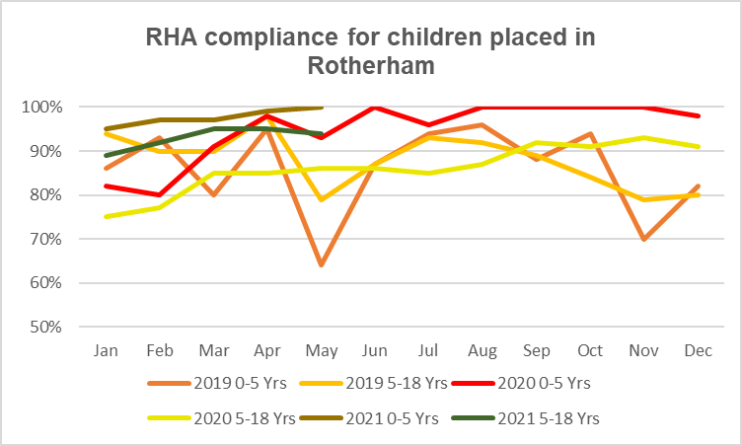

The above graph highlights the improvements made for those children placed in Rotherham, whose RHAs are undertaken by the TRFT LAC team. The nurses have shown adaptability, tenacity and a passion for our LAC throughout the pandemic, working in new ways and with restrictions. Despite these challenges, the team have improved and maintained performance as shown.

* **Service update**

The aim of the dedicated nursing team was to provide high quality, consistent health intervention with advice and support to children, young people, their carers and involved professionals, therefore providing a ‘golden thread’ of continuity.

A comment from the LAC Council (a group of Looked After Young People in Rotherham) during a consultation prior to the nursing team being developed was…

“***It would be more ideal that you could keep the same person so that nothing gets lost or forgotten in the process of changing, and having the same person can help us gain trust with them.”***

However, at this year’s Health Consultation at the LAC Council, young people indicated that health assessments have improved substantially, with young people being allowed to suggest having them at home where they feel more comfortable in a familiar environment and feel they have some control over what is happening to them rather than having the health assessment ‘done to them’ as they felt in the past. They had greater familiarity with the health assessor who they have met several times; only one young person wanted to change their health assessor.

This positive feedback from the young people at the heart of the service was welcomed by the team, and reinforces the need for the consistency and continuity of care, and its importance to young people in building positive relationships.

Carers have also provided email feedback regarding the positive impact of consistency and continuity…

***“I wish to express how pleased I am with the help received from our LAC Nurse this year, she has consistently supported us, and has built a trusting relationship with my foster daughter.”***

It is reassuring that carers are identifying an improvement in the nursing service, and the positive impact this is having.

In order to support the nursing team 1:1 safeguarding supervision is integral to our work, alongside peer support and clinical supervision.

Following the successful South Yorkshire and Bassetlaw Looked After Children’s Conference in March 2020, which was funded by NHSE Safeguarding North region and hosted by Rotherham CCG, planning has commenced via a task and finish group in relation to topics to be included in a further Conference later this year. Currently it is uncertain if this will be virtual or face to face.

The nursing team have commenced attendance at a support group for foster carers of babies and children under 5, where health support and advice can be shared with the foster carers. This has also now developed into health training sessions within this session in partnership with the Health Inclusion Team and the fostering service. Foster carers are finding this input very useful, and raises the profile of health and our team.

A significant project that the LAC nursing team and the Health Improvement Team have participated in is a dental project for Looked After Children. Due to the impact on dental services during the pandemic, access to dentists has been extremely challenging, therefore this project has enabled some of our most vulnerable children and young people to access this valued service.

This has been an exciting, challenging and positive year for the Looked After Children and Care Leavers Service, and we are passionate about the high quality care we deliver and are committed to continue to develop and improve in our service delivery.

Safeguarding Governance arrangements

Over the last 12 months the focus on a robust Trust safeguarding and external governance structure has remained a key priority (Refer to Appendix 3).

The responsibilities of all staff employed by the Trust for safeguarding children and adults are documented in the TRFT Safeguarding Policy. In addition to this there are a number of supporting policies and procedures which guide and support Trust staff.

The Chief Executive is the accountable officer. The Safeguarding Executive lead is the Chief Nurse and the Corporate/Operational Lead for Safeguarding is the Head of Safeguarding.

The Trust has two specific Safeguarding meetings: a monthly Operational Safeguarding Group chaired by the Head of Safeguarding and a quarterly Safeguarding Strategic Group, chaired by the Head of Safeguarding and latterly by the Chief Nurse, reporting to the Clinical Governance Committee. Arrangements for the chairing and governance of both groups was reviewed in 2020 following CQC’s inspection.

The role of the Strategic Safeguarding Group is to ensure processes within the Trust are in line with the current legal framework and national guidance, promoting the well-being and safeguarding of vulnerable patients whilst in the care of the Trust. In addition to Trust colleagues, membership includes representation from external partners from the Clinical Commissioning Group, the Rotherham Safeguarding Adult Board, the Local Safeguarding Children Partnership, RMBC Children and Adult Safeguarding and Public Health. This Group seeks to provide assurance on all matters relating to safeguarding and reports to the Board of Directors via the Quality Committee.

TRFT are represented on the Rotherham Safeguarding Adult Board and on the Rotherham Safeguarding Children Partnership by the Chief Nurse. The deputy for these meetings is the Head of Safeguarding.

There are a number of Safeguarding Board/Partnership delivery groups that have TRFT representation from named professionals within the team. The Performance and Quality Sub group of the Rotherham Safeguarding Adult Board is chaired by the Head of Safeguarding.

A summary report regarding key points from these delivery groups is submitted to the Operational Safeguarding Group to share information and to provide transparency and joined up working.

A ‘Safeguarding Strategy on a page’ is in place and sets out our strategic direction of Safeguarding. This is underpinned by a robust work plan. This was considered an excellent approach and the same approach is used for other Trust Service Strategies.

The Trust is required to satisfy the requirements of the Safeguarding Key Performance Indicators (KPI) and Safeguarding Standards, as set by the Clinical Commissioning Group. These include offering assurance on a diverse range of safeguarding activity throughout the Trust and are reported quarterly. Over the year the CCG has commended the Trust for the development of such a robust assurance system and process (Refer to Appendix 3).

In June 2019/20 NHS(E) led an inspection of the Trust’s safeguarding team. This was a valuable exercise which led to a number of actions to progress the safeguarding team’s work plan and supported the preparation of the Trust for the expected CQC inspection which took place in July 2020 and again in July 2021.

CQC Improvement Plan

In June 2020, CQC conducted an inspection across our children’s pathway. From this a comprehensive CQC improvement plan was developed. This was completed on schedule, with over 180 actions specified. As a result of this, there have been significant improvements in practice within TRFT across all services linked to our children’s pathway.

The improvement plan addressed a number of aspects of safeguarding arrangements including:

* **Governance**

TRFT’s governance arrangements have been reviewed and strengthened to ensure that there is appropriate engagement at our specific safeguarding meetings, ensuring divisional ownership of safeguarding practice and better flow of information from ward to Board and back.

The ToR of both groups have been updated to ensure that these groups are effective in providing challenge across services, ensuring that safeguarding practice meets the required standards.

Safeguarding is now a standing agenda item on all divisional governance meetings and the safeguarding team are represented across the divisions’ governance meetings.

* **Policy & Guidance**

All policies have been reviewed to ensure that they are in line with current legislation and guidance, and are relevant to practice.

Practice resolution has been of an awareness raising campaign and has been discussed through a variety of means, such as training, supervision, daily huddles, case discussions, peer reviews and advice calls.

A new TRFT guidance document has been developed and made available to all staff to ensure that they are familiar with the process and can easily access this if necessary. This links with the Partnership Practice Resolution Protocol. The safeguarding team have actively been developing staff skills to professionally challenge at the earliest opportunity seek a resolution using this process.

A training need was identified for paediatric staff in acute areas which led to the development of a bespoke training package on ‘professional curiosity’.

* **Practice**

Safeguarding huddles have been embedded in maternity, UECC and paediatric wards, initially implemented five days per week but now held seven days per week to cover the risk area of weekends. This allows the teams to come together and discuss the management and planning for their safeguarding cases.

The safeguarding team support this Monday to Friday. These are audited monthly to provide assurance that safe planning is in place for children, and children are discharged safely with multiagency plans as required. Any cases for escalation can be taken to the additional case discussion meeting, or if necessary, the practice resolution process is utilised Any resulting themes are discussed at the partnership group meeting.

* **Safeguarding Supervision**

Safeguarding supervision is used to support reflection and learning across practitioners who work with children. Supervision arrangements now include peer-review for medical staff, 1:1 supervision for case-holders and group supervision. Compliance with supervision is monitored via ESR.

The safeguarding team have provided one training session with the plan for three additional training sessions in 2021/22 to increase the number of safeguarding supervisors across the children’s pathway. This is in response to a number of existing supervisors having left the Trust or retired and in an attempt to improve compliance in departmental areas.

The additional supervisors, following sign-off of their competency, will be able to provide support within their area of work to complement the existing offer from the safeguarding team.

* **Training**

As a result of the CQC improvement plan, TRFT have developed and introduced a training strategy and programme using the TRFT Think Family principles. The newly combined children and adult training promotes staff to be more professionally curious, to contextualise information and to consider the wider picture rather than solely focus on the information the child or patient provide. This is in its early stages, however is evaluating well. It is supported by a practice ‘toolkit’.

The training uses a Serious Adult Review for discussion, reflection and learning, focusing on various safeguarding elements, allowing for Trust processes and policies to be discussed as part of this training as well as wider partnership processes, with the aim to embed these within practice.

A refreshed, bespoke ‘new-starter’ programme has been developed aimed at medical colleagues, to ensure that they are familiar with TRFT process and able to discharge their accountability in safeguarding our patients. The training package is more robust with a practical application using case scenarios and is delivered in conjunction with Children’s Social Care manager and safeguarding team to emphasise Working Together to Safeguard Children, thus reinforcing multiagency arrangements.

In addition, maternity services have responded to new starter need and provided four bespoke sessions to support the newly qualified staff acknowledging the pressures of qualifying during the pandemic.

In order to improve the quality of the children’s referrals to children’s social care, the safeguarding team have promoted the rolling training: Quality Child Safeguarding (eMARF) referrals. The training incorporates a practical application to the use of the Rotherham Multiagency Threshold Descriptors and importantly empower staff to consider and evidence “the voice of the child” when completing any referrals.

* **Audit**

A number of audits across the divisions were identified from the improvement plan. All were completed to schedule.

These included audit related to the quality of the electronic Child Safeguarding referrals (EMARF) referrals, effectiveness of the safeguarding huddles with discharge planning, Think Family documentation and assessment, 16 + 17year-old pathway, compliance with safeguarding checks, implementation of the MCA, Child Protection Medical Assessment process and the use of Body Maps. These audits all have action plans and the learning from each audit was cascaded out to the relevant area via a summary ‘report on a page’. All audits are reported on either through the Operational Safeguarding meeting or divisional governance meetings and monitored by the clinical effectiveness department.

* **Patent Safety**

TRFT completed a thematic review of serious incidents, which allowed us to focus on the common themes and target additional resources in these areas.

Going forward, as there have been no safeguarding related Serious Incidents since February 2020, the safeguarding team will review all datix related to safeguarding issues, and use this to target our resources, providing support and training to ensure staff are developing confidence and competence.

Risks and Mitigation

The following risks have been identified and managed throughout the last 12 months. Performance is reviewed and risks are monitored through the Operational Safeguarding Group and the Strategic Safeguarding Group.

All risks are included on the Chief Nurse Risk Register and managed accordingly.

1. Safeguarding Children Training Compliance
2. Child Protection E-MARF forms process
3. Implementation of the MCA
4. Management of injuries to infants under 2 years, including non-mobile babies

**Description of Risk and Control Measures**

1. **Safeguarding MaST Training Compliance**

The risk is in relation to TRFT colleagues not accessing the required level of safeguarding training, which may impact on their competence when required to assess safeguarding risk for children and adults. This is an approved risk with a score of 10 (High Risk).

**Mitigations**: The Safeguarding Team continue to receive monthly compliance reports. Colleagues receive a three-monthly reminder to complete their training from ESR.

The training offer during COVID has been made available, where possible, through Teams to ensure all staff can access training as normal. The E-learning package remains in place to provide core competency updates for safeguarding children, with the additional packages to support the additional hours required.

Training compliance is monitored and escalated via the Operational and Strategic Safeguarding Groups.

**2. Child Protection E-MARF forms process**

This risk is in relation to RMBC making changes to their domain address which has impacted upon the generation of an electronic referral receipt back to TRFT colleagues when making a ‘worried about a child’ referral (e-MARF). For TRFT colleagues this has meant that a copy of the referral was not provided for saving in the child’s records. This is a managed risk with a score of 6 (Moderate Risk).

**Mitigations:** As an interim measure, TRFT colleagues were advised to record the reference number of the submitted referral and record the concerns on the safeguarding template (if a SystmOne user) or in the Child’s health record (if not a SystmOne user).

There has been extensive liaison between TRFT and RMBC involving coordinated contact with NHS.net. There is now a temporary IT measure in place that allows a copy of the referral to be received within the TRFT Safeguarding Team, and further work is in progress to find a permanent solution.

1. **Implementation of the MCA**

The risk relates to providing evidence to support the continued and consistent implementation of the MCA & Deprivation of Liberty Safeguards (DoLS) throughout the Trust. This risk now includes Liberty Protection Safeguards (LPS) and how this will be implemented within the Trust.

**Mitigations:** There is continued input from the Adult Safeguarding Team to support and develop staff across the Trust to evidence their use of the MCA and DoLS in practice, and to be competent and confident in this. A variety of training has been provided throughout the period to support staff, as well as work progressed to ensure that the mental capacity assessments and best interest decisions can be recorded on the electronic patient record. This is a managed risk with a score of 6 (Moderate Risk).

The Adult Safeguarding Team have completed audit which demonstrated an overall baseline assurance that 87.5% of staff are completing MCA documentation. This audit will be repeated in 2021/22.

1. **Management of injuries to infants under 2 years, including non-mobile babies**

There is a risk of injuries in infants under two years, including non-mobile babies, being inappropriately clinically managed and not giving appropriate consideration to wider safeguarding issues which may be present. The concerns involve staff potentially failing to recognise wider concerns related to injuries in this group of patients and staff potentially failing to follow local policy and procedure when these cases present. This is particularly relevant where there may be temporary/Locum staff who are unfamiliar with TRFT policy and process for managing these issues. This carries a risk that appropriate single and multi-agency intervention to reduce risk and prevent further injuries to this group may be delayed.

**Mitigations:** The ‘Bruising in non-mobile babies’ pathway has been developed. This is now included in the Rotherham M/A procedures. A Child Safeguarding Risk assessment tool was developed within TRFT and has been approved for wider partnership use.

The safeguarding team has provided reinforcement of the appropriate management of these cases.

Case supervision and daily safeguarding Huddles have been implemented within UECC, Children's Ward, SCBU and Midwifery. Work is ongoing to embed the use of body-mapping across these services.

There has been development of the Child Protection Medical Assessment Policy and an increased focus on Partnership working, to ensure timely sharing of concerns and learning from cases.

TRFT new starter training has been refreshed for medical colleagues and use of case scenarios to reinforce multiagency safeguarding procedures.

This is an approved risk with a score of 8 (High Risk).

Summary and Conclusion

TRFT Safeguarding and Vulnerabilities Team continue to engage with Trust services and partner agencies throughout the Borough to develop and progress the safeguarding service to ensure our organisation, staff and patients are safe at all times. The workload has continued to increase across adults and children’s work streams in relation to changes to legislation and national statutory guidance, but also due to the increased demand locally for safeguarding input across a wide range of areas, the actions required to implement the CQC Improvement Plan and accommodating the demands placed on our service, and the NHS by Covid-19.

In spite of these challenges, the Safeguarding & Vulnerabilities Team have continued to improve the support available across the Trust, assisting TRFT staff to incorporate safeguarding into their daily work load and ensuring good outcomes.

The Safeguarding team are committed to ensuring all systems and processes support the early identification of safeguarding concerns and promote an approach which has the voice of the child or adult at risk at the forefront of care delivery throughout the Trust. The positive impact of the CQC implementation plan is now evidencing the improved engagement and ownership of safeguarding matters across all divisions of the Trust.

Improvements in governance arrangements are set to continue, with review of the Terms of Reference of both Trust safeguarding groups to ensure that these meetings deliver on their objectives and can offer assurance on safeguarding activity throughout the Trust.

Covid-19 has forced a new way of working on services, which our team have adapted to positively, and used to progress the safeguarding agenda, both within our Trust and externally with our partners. It has resulted in some positive impacts, with improved attendance at meetings and stronger links with our LA partners to ensure that safeguarding arrangements are robust and continue to be developed and progressed as we move towards recovery.

Novel training approaches have been put in place, virtual safeguarding supervision and Teams meetings utilised to ensure that the business of safeguarding within TRFT did not lose any momentum in the circumstances.

The Safeguarding and Vulnerabilities Team have developed a robust work plan, which is monitored and updated regularly and will continue to support safeguarding practice in the coming year throughout our Trust.

Future Priorities

**The Safeguarding Team have identified a number of key priorities for 2021-2022 to strengthen safeguarding arrangements for the Trust:**

* To achieve all safeguarding contracting Standards and Key Performance Indicators.
* To improve the evidence available demonstrating compliance with the MCA & DoLS requirement and transition to the Liberty Protection Safeguards (LPS) arrangements.
* To progress towards Autism Accreditation for UECC to ensure that this patient group has access to high standards of care.
* To continue to support all staff to achieve compliance with safeguarding policy, procedure, training and supervision.
* To continue to work on improving the quality of safeguarding referrals to the local authority, both in children and adults.
* To develop a safeguarding referrals database providing opportunity to theme the topics of referrals in order to influence safeguarding training for the workforce.
* To develop a MASH Baby Clinic process to discuss any pregnant Mother’s safeguarding risk and make the relevant referrals to children’s social care in as timely a manner as possible.
* To work collaboratively with our Trust colleagues to manage the ongoing challenges of Covid-19, ensuring that staff continue to feel supported in keeping vulnerable people safe and the Trust is prepared to manage any increased demand on our services.
* To conduct a ‘deep dive’ of a range of the actions covered through the CQC improvement plan. This will allow for new practices to be tested and assessed, helping us to identify the impact of the changes made.
* To improve our care of patients who have poor mental health by partnership working with RDaSH.
* To continue to increase workforce competence through developing knowledge and skills within the adult and children’s safeguarding champions.
* To continue to work with divisions and IT to develop the e-safeguarding templates on Meditech and support with the implementation for use in practice.

Safeguarding Performance Summary on a Page – Information for Q1 2020/2021

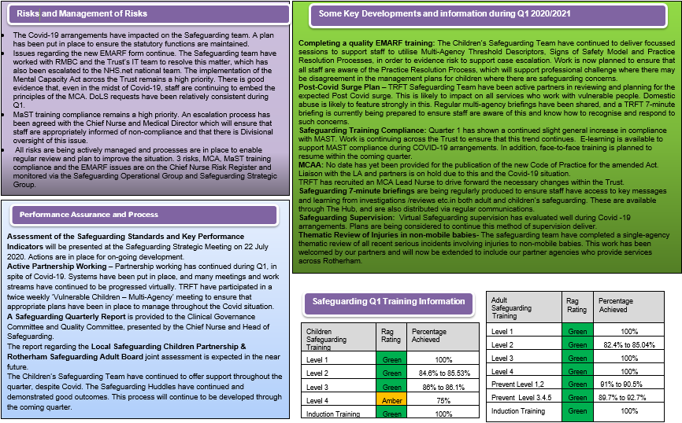

Safeguarding Performance Summary on a Page – Information for Q2 2020/21

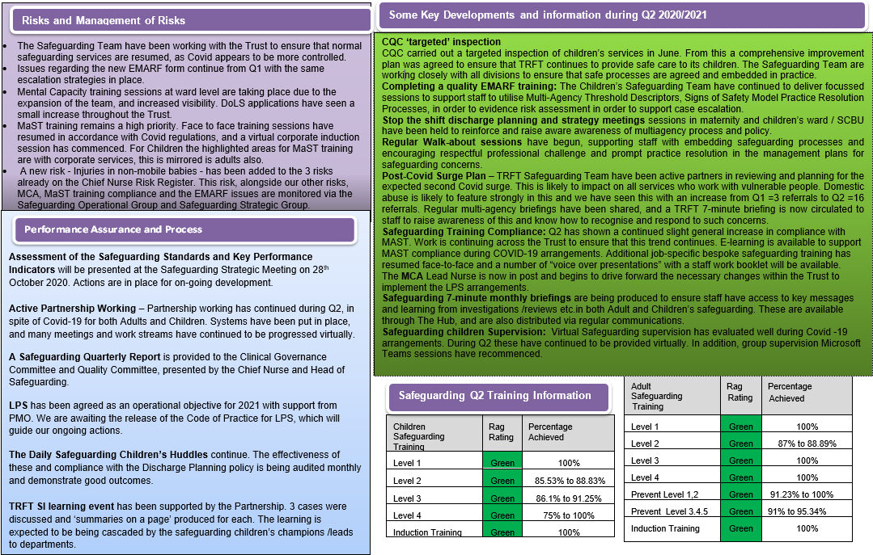

Safeguarding Performance Summary on a Page – Information for Q3 2020/21

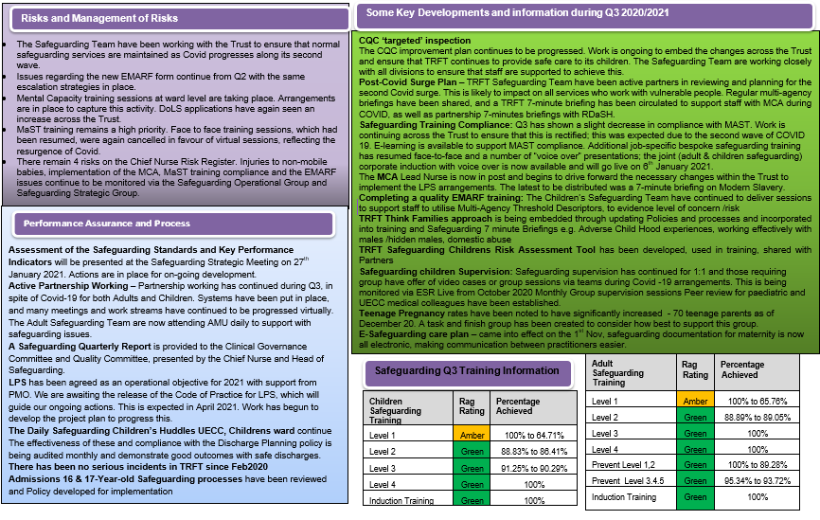

Safeguarding Performance Summary on a Page – Information for Q4 2020/2021

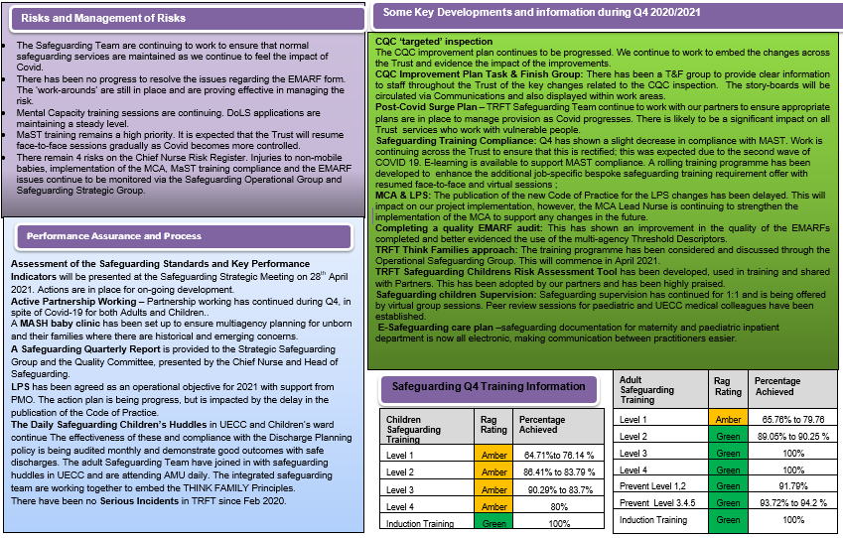

TRFT Strategy for Safeguarding Vulnerable SerVICE USERS Appendix 1

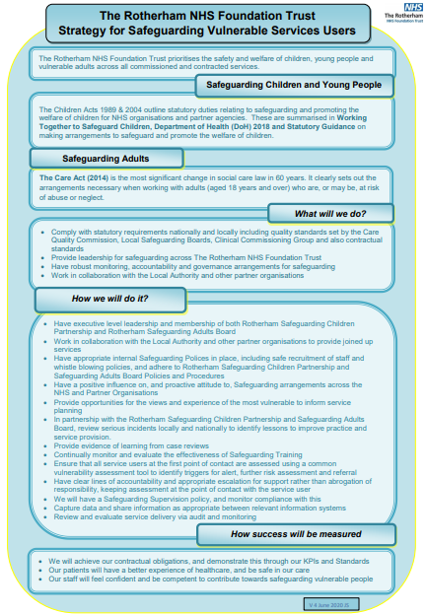

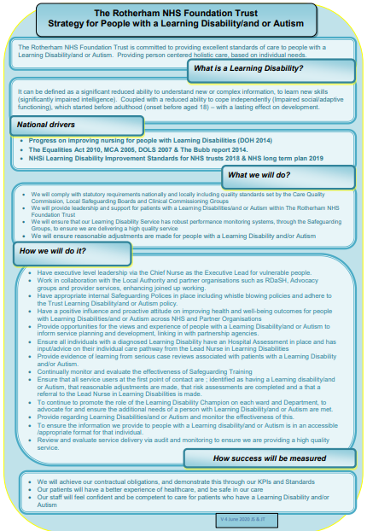

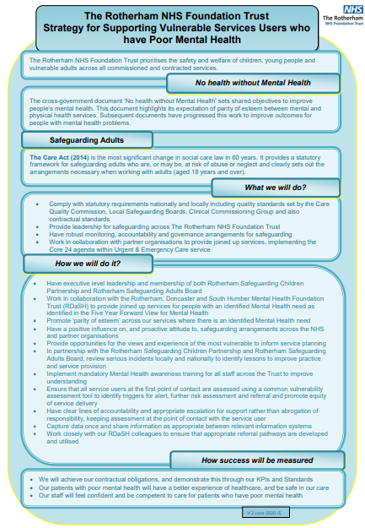

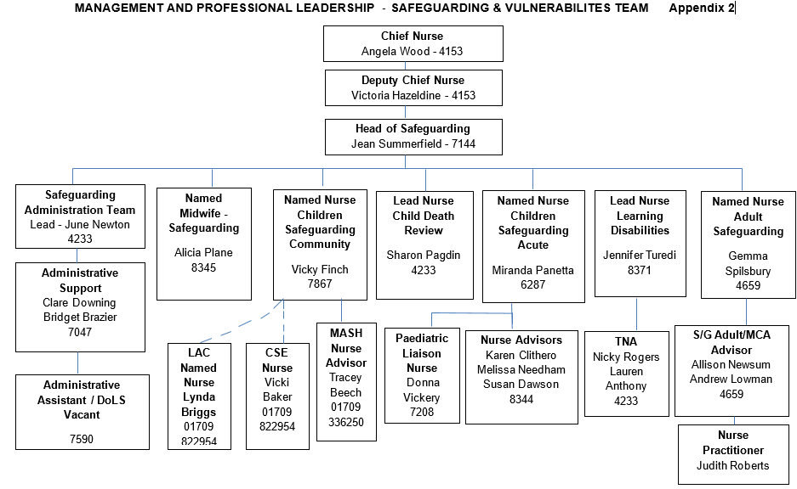

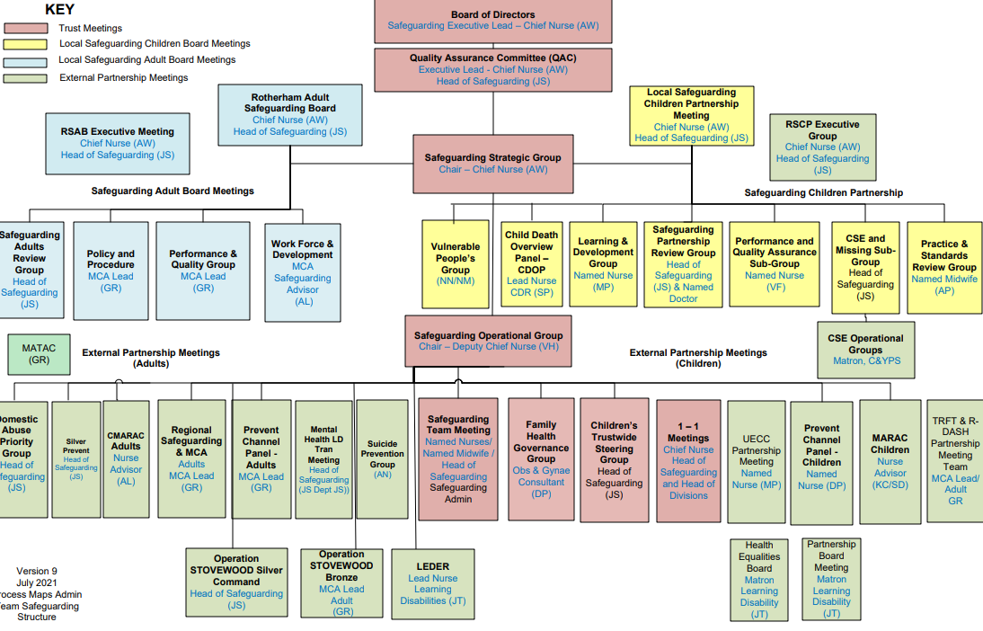

Appendix 3

Safeguarding Standards – Exception Report Appendix 4

This exception report includes areas of non-compliance over the financial year 20/21. It serves to demonstrate progression, and identifies areas for future development, which will be incorporated into the work streams.

|  |  |  |  |  |  |
| --- | --- | --- | --- | --- | --- |
| Safeguarding Standards | Q1 | Q2 | Q3 | Q4 |  |
| **Standard 5 - Training** |  |  |  |  |  |
| 5.1 The provider will ensure that all colleagues and volunteers undertake safeguarding training appropriate to their role and level of responsibility and that this will be identified in an organisational training needs analysis and training plan. This training needs to include:  ● LAC . ● Prevent  ● FGM  ● CSE  ● MCA/DoLS  ● Domestic Abuse  ● Modern Slavery (including Human Trafficking)  ● Neglect & Self Neglect | Children & Adult |  |  |  | Ref 574 Safeguarding Vulnerable People Policy  All new starters receive safeguarding introductory presentation with Q & A from safeguarding team on induction. New and existing staff receive an annual leaflet on safeguarding which satisfies level 1 training.  Extensive collaborative work is ongoing to ensure that staff have the appropriate level of children's and adult's safeguarding training assigned to them which has been agreed by the subject matter expert and the local manager in line with the release of both the Adult and Children's Intercollegiate documents.  In respect of level two safeguarding adults training, elearning options have been put in place and additional units attached for MCA.  In respect of Level two and Level three children’s training, eLearning modules are in place with the additional option for face to face multi-agency training at L3.  Additional bespoke training is offered to support learning and any current topical themes.  PREVENT training is aligned with Children's safeguarding training requirements in line with the most recent NHS England guidance. full review of training has taken place during March 2021 |
| 5.3 The Provider will ensure that all colleagues undertake safeguarding training in line with national and local expectations. This includes safeguarding updates as a minimum of 3 yearly and an annual written update. The provider will ensure that all Board level staff receive additional to the level 1 requirement, safeguarding training as per Intercollegiate documents (children & adults). |  |  |  |  | Provision is in place for all relevant training for all colleagues, however training figures although excellent in some areas need further progress (see KPI information) Training has been reviewed during March 2021 with a programme identified for the year for Level 2 Adults and Children, and Level 3 children and Levl 2 adults full day training |