FOI Ref: 6586
Category(ies): Staff - Structure
Subject: Communications Teams
Date Received: 26/08/2022

Your request: | Our response:
- Number of staff employed by your Trust who work in the following roles: Marketing, PR, Communications, Media/Press Office, Engagement. Please include permanent staff and those on fixed term contracts. | 7 – Communications Team  2 – Patient Engagement and Inclusion Team, however this team does not sit within the Communications Team
- Grade and whole-time equivalent numbers for these staff (for example, Communications Assistant, band 3, 0.5WTE, Communications Manager, band 8A, 1WTE) | Communications Team  Communications Manager, Band 7, 1WTE  Media & Communications Officer, Band 5, 1 WTE  Communications Officer, Band 5, 1WTE  Digital Communications Assistant, Band 4, 1 WTE  Communications Assistant, Band 2, 0.8 WTE  Graphic Designer, Band 6, 1WTE  Graphic Artworker, Band 4, 0.4 WTE  Patient Engagement and Inclusion Team  Engagement and Inclusion Lead, Band 7, 0.80 WTE  Engagement and Inclusion administrator, Band 3, 0.20 WTE.
- Any structure charts for your Communications Department or equivalent.

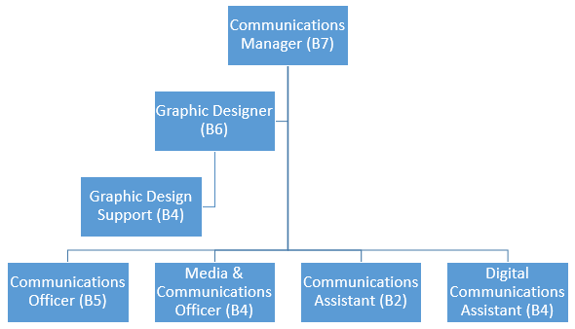

- Type of Trust (for example, Ambulance, Acute, Community, Mental Health) | Acute and Community Trust
- Number of staff employed by your Trust | 4851

